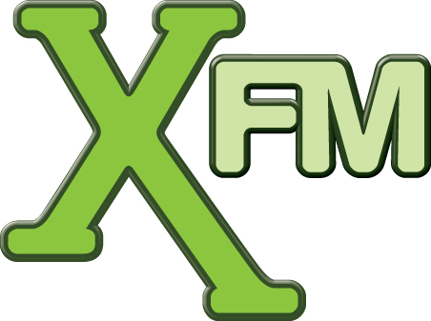

30 November 2007

Dear all

A few of you have been asking what is happening with regards to the Saturday night slot on XFM.

James Hyman has left the station to concentrate on his other TV/Film projects. In his 7 years at Xfm, James co-presented & produced the Sony Award nominated 'Remix' which bought 'mash-ups' to the masses and since 2000 his 'Rinse' show soundtracked Xfm's Saturday nights. We thank him for his involvement and wish him the best of luck with everything for the future.

Jon Hillcock will be covering this slot for the time being, and I will announce what we are doing with this show ongoing in the next month or so.

Thanks

Adam Uytman
Programme Director
XFM London

Xfm plays the best indie-rock music and is available in London on 104.9FM in Scotland on 105.7-106.1FM in Manchester on 97.7FM and coming soon to South Wales on 106.8 – 107.3. Xfm is also available nationally on Sky digital, Virgin Media, HomeChoice and online at www.xfm.co.uk.
You can also listen to Xfm on DAB digital radio in most major UK cities.

Xfm is part GCap Media and has recently been vote ‘Media Brand of the Year’ at the Media Week Awards 2007.

